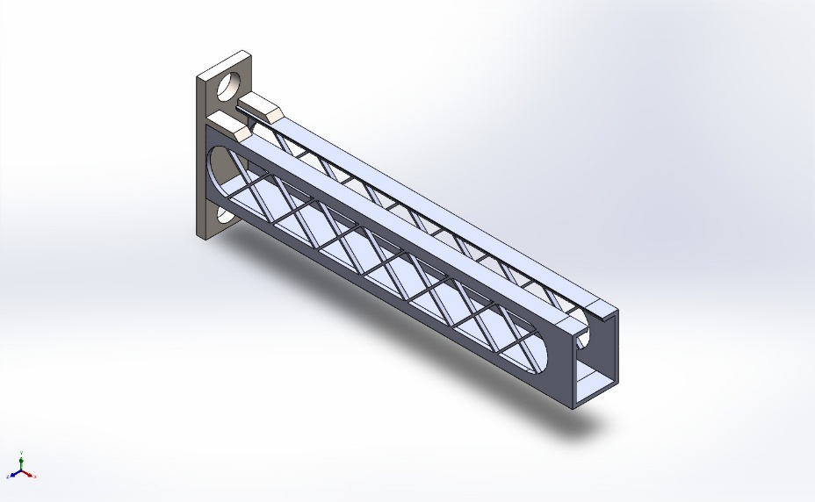
  Simulation of Cantilever Bracket
  Date: 04 June 2026
  Designer: Solidworks
  Study name: Dynamic 1
  Analysis type: Linear dynamic analysis (Harmonic)
  Table of Contents
  Description 1
  Assumptions 2
  Model Information 3
  Study Properties 5
  Units 5
  Material Properties 6
  Loads and Fixtures 7
  Connector Definitions 8
  Interaction Information 9
  Mesh information 10
  Sensor Details 13
  Study Results 14
  Conclusion 16

Description
No Data

Assumptions

Model Information

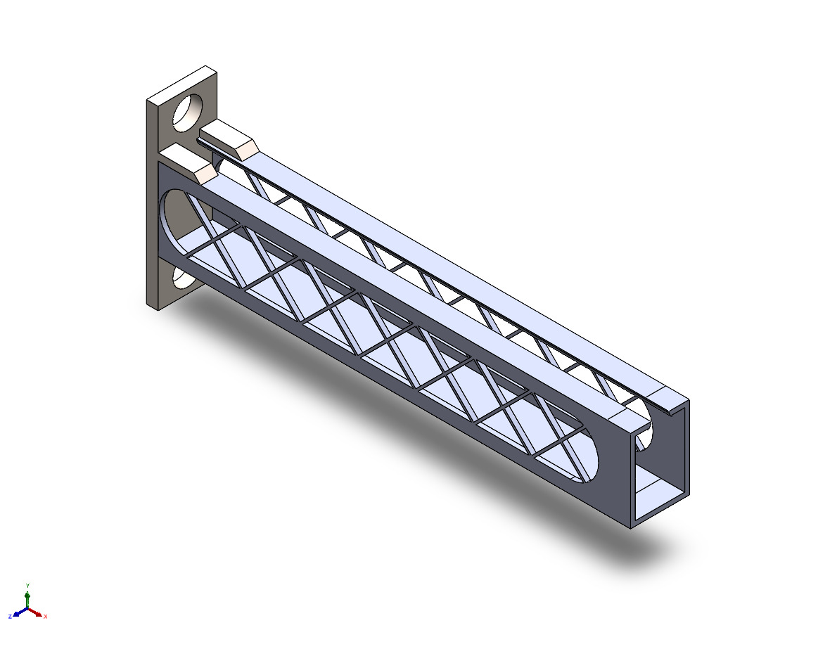
Model name: Cantilever Bracket
Current Configuration: Child Reborn
Solid Bodies
Document Name and Reference | Treated As | Volumetric Properties | Document Path/Date Modified
Mirror7  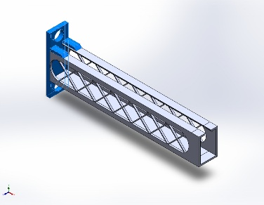 | Solid Body | Mass:68.4554 kg  Volume:0.00889032 m^3  Density:7,700 kg/m^3  Weight:670.863 N | C:\Users\asus\Documents\Solidworks assignments\Chair\Cantilever Bracket.SLDPRT  Jun 4 01:05:05 2026
Cut-Extrude2  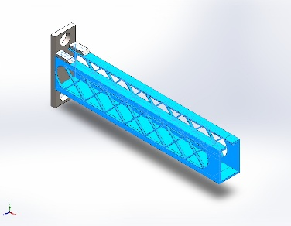 | Solid Body | Mass:201.365 kg  Volume:0.0261513 m^3  Density:7,700 kg/m^3  Weight:1,973.38 N | C:\Users\asus\Documents\Solidworks assignments\Chair\Cantilever Bracket.SLDPRT  Jun 4 01:05:05 2026

Study Properties
Study name | Dynamic 1
Analysis type | Linear dynamic analysis (Harmonic)
Mesh type | Solid Mesh
Number of frequencies | 15
Decouple the mixed free body modes | Off
Solver type | FFEPlus
Soft Spring: | Off
Incompatible bonding options | Automatic
Thermal option | Include temperature loads
Zero strain temperature | 298 Kelvin
Include fluid pressure effects from SOLIDWORKS Flow Simulation | Off
Lower frequency limit | 0 Hz
Upper frequency limit | 100,000 Hz
Number of frequencies | 15
Interpolation | Logarithmic
Result folder | SOLIDWORKS document (C:\Users\asus\Documents\Solidworks assignments\Chair)

Units
Unit system: | SI (MKS)
Length/Displacement | mm
Temperature | Kelvin
Angular velocity | Rad/sec
Pressure/Stress | N/m^2

Material Properties
Model Reference | Properties | Components
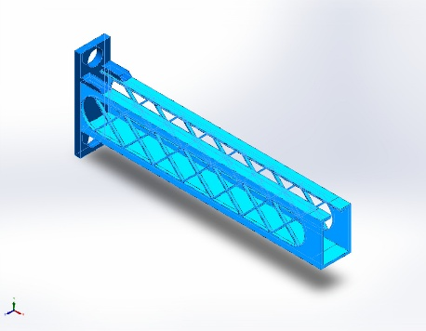 |  | SolidBody 1(Mirror7)(Cantilever Bracket),  SolidBody 2(Cut-Extrude2)(Cantilever Bracket)
  Name: | Alloy Steel
  Model type: | Linear Elastic Isotropic
  Default failure criterion: | Max von Mises Stress
  Yield strength: | 6.20422e+08 N/m^2
  Tensile strength: | 7.23826e+08 N/m^2
  Elastic modulus: | 2.1e+11 N/m^2
  Poisson's ratio: | 0.28
  Mass density: | 7,700 kg/m^3
  Shear modulus: | 7.9e+10 N/m^2
  Thermal expansion coefficient: | 1.3e-05 /Kelvin
Curve Data:N/A

Loads and Fixtures
Fixture name | Fixture Image | Fixture Details
Fixed-1 | 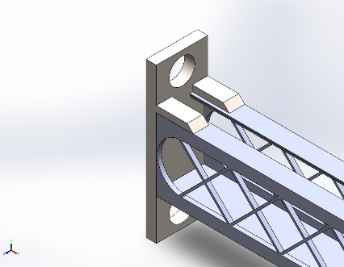
  Entities: | 1 face(s)
  Type: | Fixed Geometry
Resultant Forces
Components | X | Y | Z | Resultant
Reaction force(N) | 0.0142975 | 0.0058147 | 0.00391448 | 0.0159233
Reaction Moment(N.m) | 0 | 0 | 0 | 0

Load name | Load Image | Load Details
Force-1 | 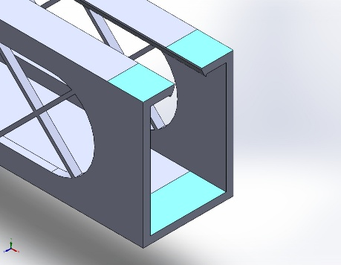
  Entities: | 3 face(s)
  Type: | Apply normal force
  Value: | 500 N
Gravity-1 | 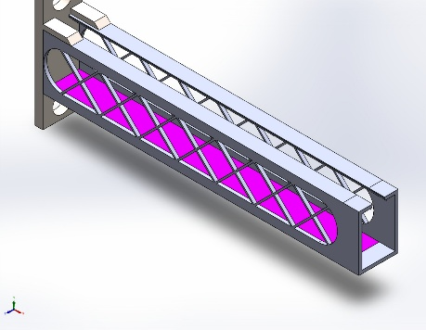
  Reference: | Face< 1 >
  Values: | 0 0 9.81
  Units: | m/s^2
Distributed Mass-1 | 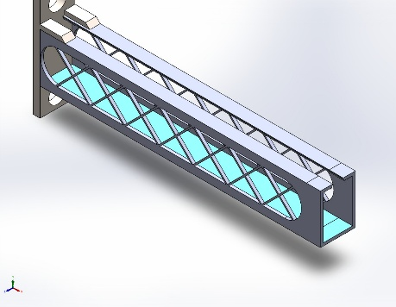
  Entities: | 2 face(s)
  Type: | Displacement (Direct transfer)
  Coordinate System: | Global cartesian coordinates
  Translation Values: | ---, ---, --- mm
  Rotation Values: | ---, ---, --- deg
  Reference coordinates: | 0 0 0 mm
  Remote Mass: | 5 kg
  Moment of Inertia: | 0,0,0,0,0,0 kg.m^2
  Components transferred: | NA

Connector Definitions
No Data

Interaction Information

Interaction | Interaction Image | Interaction Properties
Local Interaction-3 | 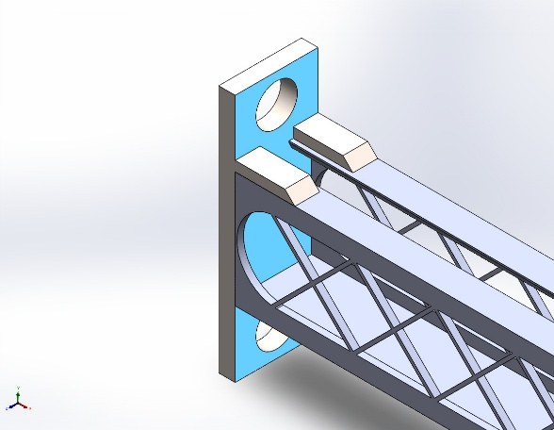
  Type: | Bonded interaction pair
  Entities: | 2 face(s)
Global Interaction | 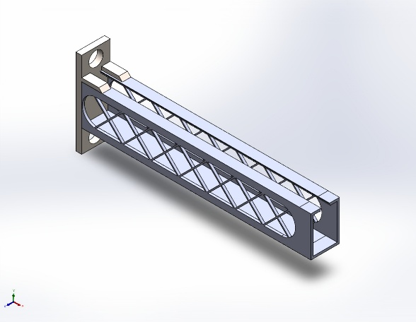
  Type: | Bonded
  Components: | 1 component(s)
  Options: | Independent mesh

Mesh information
Mesh type | Solid Mesh
Mesher Used: | Blended curvature-based mesh
Jacobian points for High quality mesh | 16 Points
Maximum element size | 275.576 mm
Minimum element size | 102.239 mm
Mesh Quality | High

Mesh information - Details
Total Nodes | 457251
Total Elements | 240160
Maximum Aspect Ratio | 7.0791
% of elements with Aspect Ratio < 3 | 95.2
Percentage of elements with Aspect Ratio > 10 | 0
Percentage of distorted elements | 0
Time to complete mesh(hh;mm;ss): | 00:00:25
Computer name:

Mesh Control Information:
Mesh Control Name | Mesh Control Image | Mesh Control Details
Control-1 | 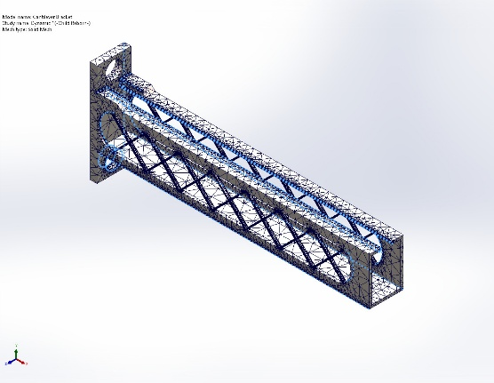
  Entities: | 25 edge(s)
  Units: | mm
  Size: | 4.8532
  Ratio: | 4.8532
Control-2 | 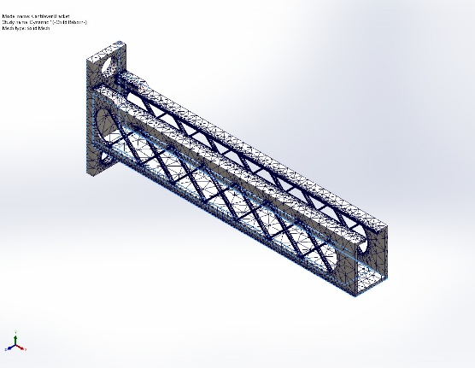
  Entities: | 26 edge(s)
  Units: | mm
  Size: | 28.5
  Ratio: | 28.5
Control-4 | 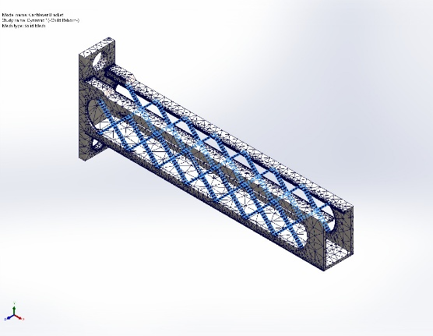
  Entities: | 224 edge(s), 1 face(s)
  Units: | mm
  Size: | 2.6846
  Ratio: | 2.6846

Mesh Quality Plots
Name | Type | Min | Max
Quality1 | Aspect Ratio | 1.044e+00  Element: 6195 | 7.079e+00  Element: 10950
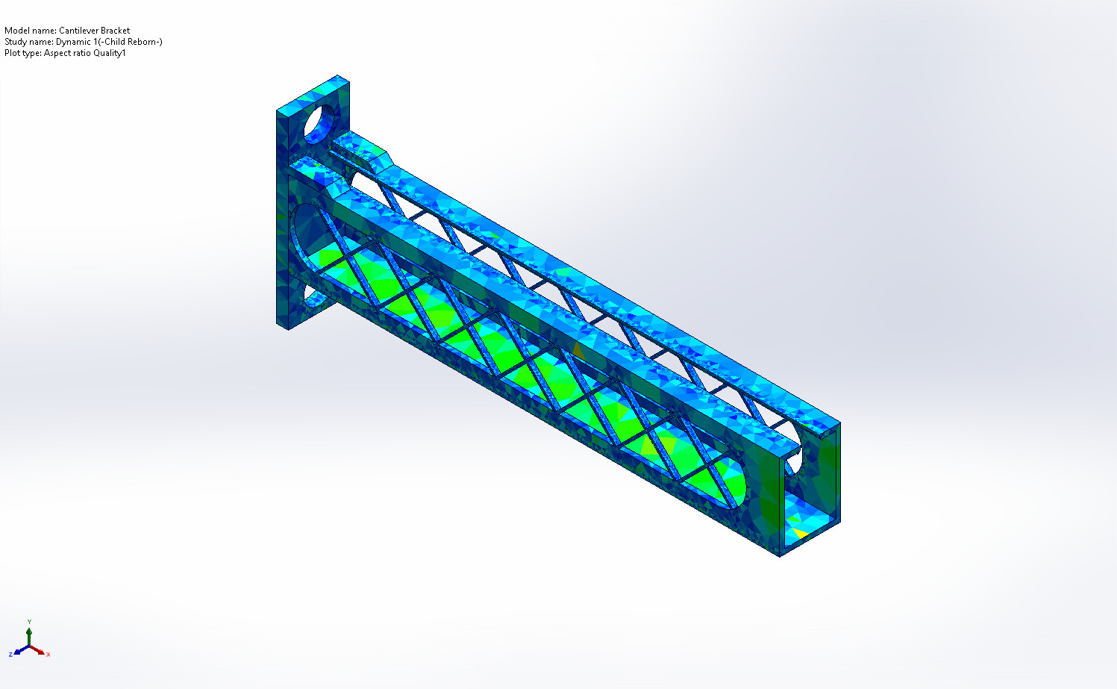
Cantilever Bracket-Dynamic 1-Quality-Quality1

Name | Type | Min | Max
Diagnosis2 | Mesh Quality Diagnostics : Aspect Ratio | 1.044e+00  Element: 6195 | 7.079e+00  Element: 10950
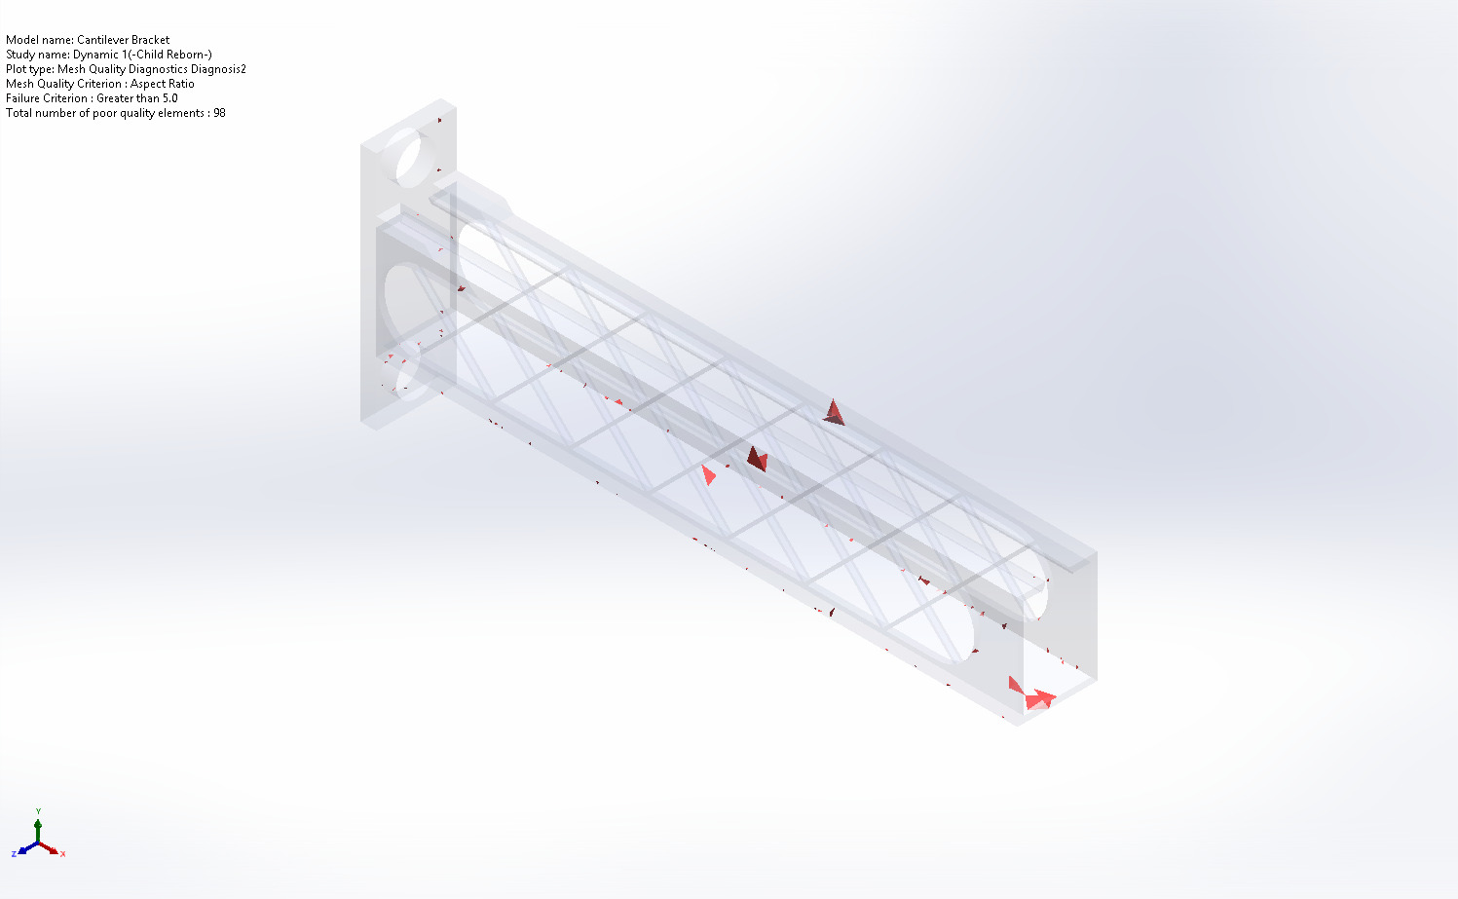
Cantilever Bracket-Dynamic 1-Quality-Diagnosis2

Sensor Details
No Data

Study Results

Name | Type | Min | Max
Stress1 | VONDC: von Mises (Directional Components) at Step No: 241(Frequency = 100,000 Hz) | 4.329e-05N/m^2  Node: 90 | 1.473e+01N/m^2  Node: 22765
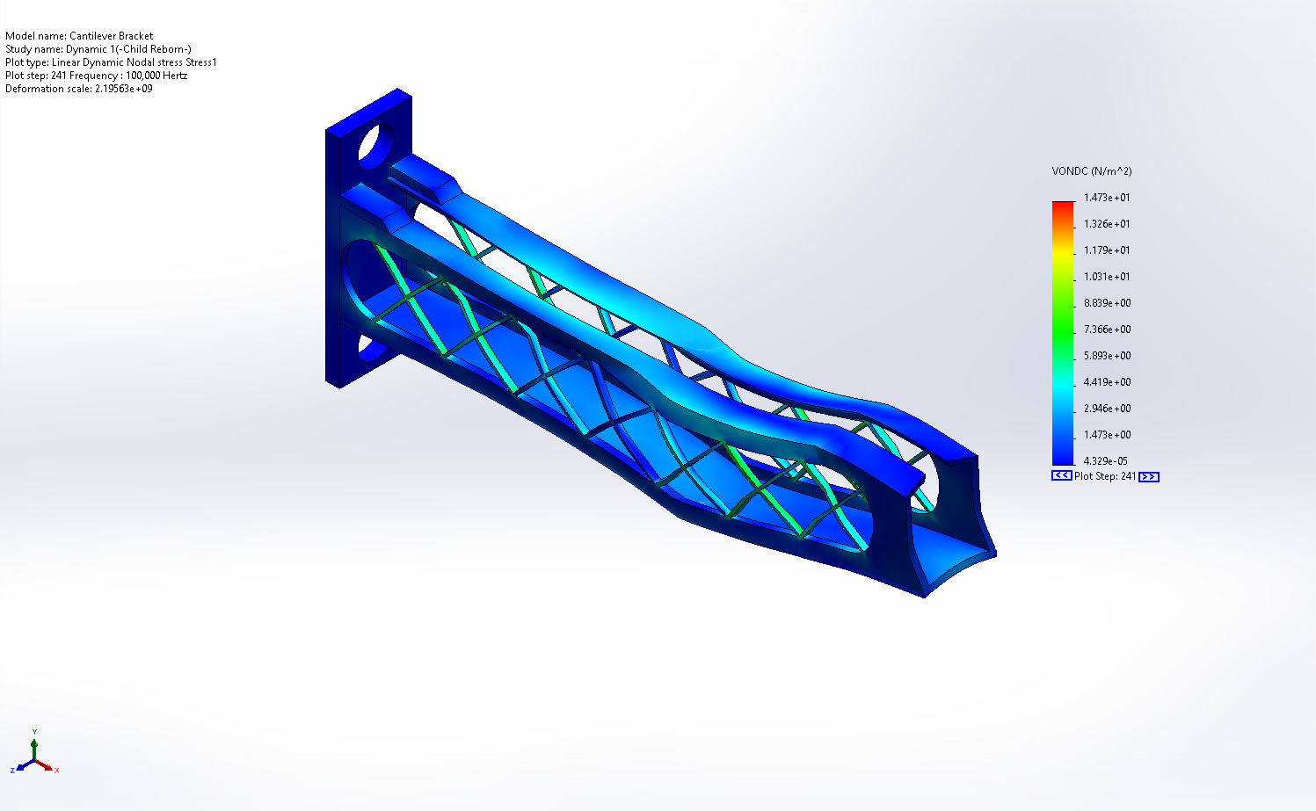
Cantilever Bracket-Dynamic 1-Stress-Stress1

Name | Type | Min | Max
Displacement1 | URES: Resultant Displacement at Step No: 241(Frequency = 100,000 Hz) | 0.000e+00mm  Node: 19 | 1.007e-07mm  Node: 23046
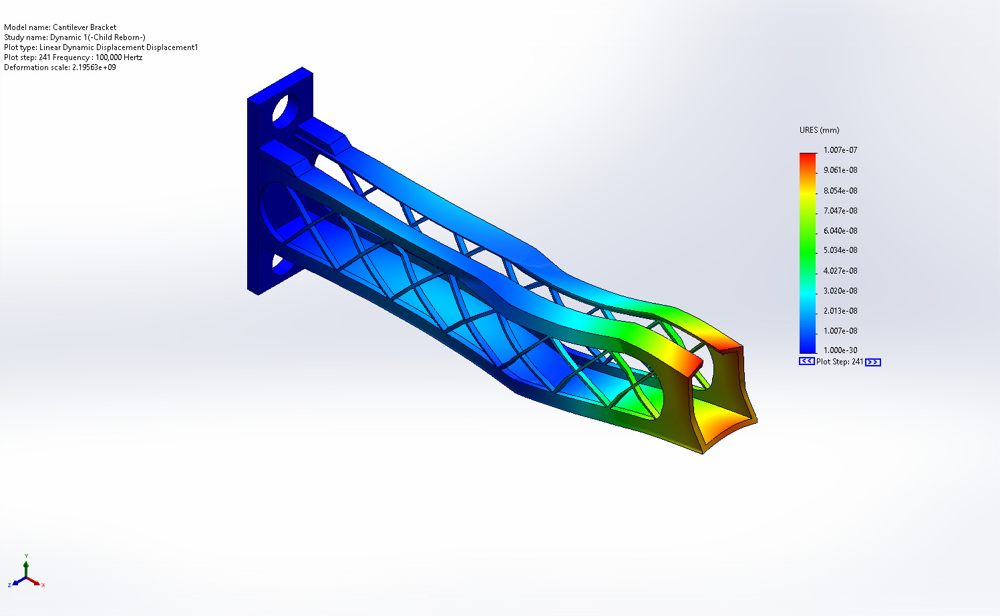
Cantilever Bracket-Dynamic 1-Displacement-Displacement1

Mass Participation (Normalized)
Mode Number | Frequency(Hertz) | X direction | Y direction | Z direction
1 | 31.903 | 2.8255e-10 | 9.064e-09 | 0.41549
2 | 59.588 | 7.7969e-08 | 0.088251 | 5.1343e-10
3 | 81.951 | 3.889e-05 | 0.41757 | 2.0548e-09
4 | 98.119 | 1.4048e-09 | 3.3136e-10 | 0.014774
5 | 135.28 | 7.4101e-11 | 5.4926e-08 | 0.08495
6 | 136.44 | 3.8666e-05 | 0.0062077 | 6.0003e-07
7 | 159.55 | 5.0216e-10 | 9.5552e-10 | 0.036216
8 | 257.92 | 1.3842e-08 | 1.2444e-07 | 0.025616
9 | 277.64 | 0.00022323 | 0.11987 | 5.3041e-08
10 | 311.29 | 0.00012878 | 0.00014461 | 2.5943e-07
11 | 324.92 | 5.5525e-11 | 1.2569e-09 | 0.028875
12 | 370.34 | 0.00066059 | 0.0095672 | 9.1565e-07
13 | 382.46 | 5.265e-09 | 4.2565e-07 | 0.022241
14 | 461.41 | 1.7631e-10 | 1.8387e-08 | 0.0010847
15 | 488.15 | 2.4763e-05 | 0.0021791 | 1.0439e-06
 |  | Sum X = 0.001115 | Sum Y = 0.64379 | Sum Z = 0.62925

Conclusion

